ABSTRACT:
Project 1: Bridge Frame Design tested students on the fundamentals of the materials learned in class. The project directs us to simulate and find the beam profile with the smallest cross-sectional area. The criteria that the different beam profiles must fulfill include being able to support a 1000N/m load, directed exclusively on one portion of the frame outlined in the description. The beam on which the load is applied can be considered a 'cantilever' beam. It only has support connected to the ground at one end, and the other end is supported through a series of mechanical systems, such as a truss. The truss was made of a hypothetical material with a Modulus of Elasticity of 200 GPa, a Failure Stress of 400MPa, and a Safety Factor of 1.5. After adequate testing of the beam frames, the results show that a vertical rectangle with infinitesimal width and infinite height would be the most efficient design for any structure with only a vertical load; however, the practicality of such a design, and why it is currently not being taken advantage of in any structures today should be discussed in further detail.

PROJECT GOAL:
The project's goal was broken down into three main parts, and work was split evenly between the group 3 members. The first hurdle to overcome was creating the ABAQUS Model and determining the specifics of how to complete the mesh. After overcoming the first hurdle, another obstacle became known: the selection of beam profiles. Group 3 members decided to test 4 beam designs: Box, I-Beam, T-Beam, and Circle. The team leader gave each group 3 members a chance to pick which beam type to work on, and this was allocated as such: Rafael worked on the T-Beam, Jacob Whisenant worked on the Circle, Jacob Vaught worked on the box, and Tristan Guerin worked on the I-Beam. The last significant step for the project was creating the report. Each member was required to create a short 100-to-300-word essay on our beam results. In addition to the short essay, Tristan was tasked with creating a PowerPoint, Rafael was tasked with Proofreading the essays and the final report, and Jacob Vaught was tasked with authoring the finalized report and combining all the graphs and photos, and essays into one coherent document. Jacob Whisenant was the Project Leader and thus oversaw all work and allocated it.

Solution Approach:
- Create a 2D planar deformable wire sketch of the Bridge Frame
- Create the material, create a section, create a profile, and create a section assignment for the truss part
- Create an instance in the assembly
- Create a new step
- Create a mesh and seed the part. Use local seeds to increase the mesh sensitivity in crucial areas for our model
- Created BCs (Boundary Conditions) and the Line Load
- Create & submit the job file
- Review the results

FINITE ELEMENT RESULTS
Each of group 3’s members’ last names are arranged with their project results.
TRISTAN GUERIN:
I was tasked with analyzing the I-Beam Profile with an ABAQUS model. The Project document gave me all the material properties, including Failure Stress=400[MPa], Modulus of Elasticity=200[GPa], and Poisson's Ratio=0.3. The Project document also Provided the general structure design with the support and load locations and the load magnitude. Fixed support was at (0,0), and roller support was at (4,0). The load was a line load with a magnitude of 1000 [N/m] over a 2-meter beam. The line load was applied between (4,0) and (6,0). The project also specified that we should have a safety factor of 1.5, so I determined that the maximum failure stress of our design could not exceed 266.6 [MPa]. I ran multiple-beam iterations, resulting in a maximum Von Misses stress of 260.7[MPa] and achieved a cross-sectional area of 1.596*10-4 (m²). Von Misses stress was chosen over the Maximum in-plane stress because it accounts for stresses acting in all three dimensions (3D), while the max in-plane stress accounts for only two dimensions (2D). The dimensions were chosen via trial and error and are shown in figure 1.

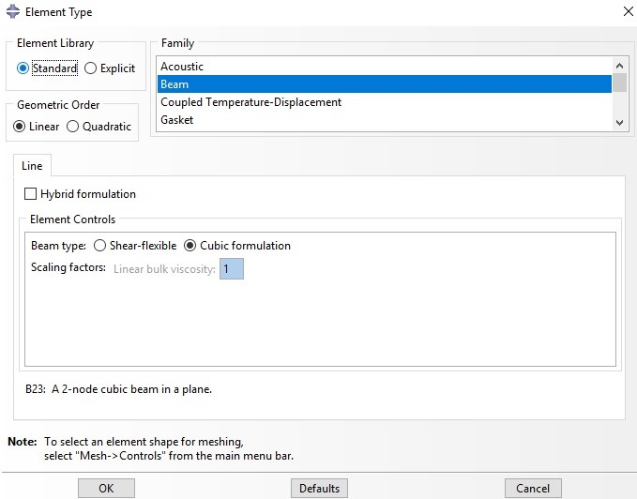
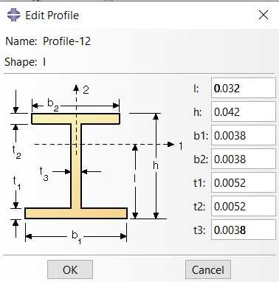
Figure 1 cross sectional dimensions of the I-Beam: Figure 2: Mesh Size

An arbitrary mesh size of 0.01 was used. See Figure 2
While the profile is technically an I-Beam, it looks more like a solid rectangle with a height of 4.2 [cm] and a width of 0.38 [cm].

RAFAEL SANCHEZ CID:
For this case, we will be testing how effective the T-beam shape is for this type of structure. As is commonly known, the T-beam has less surface area than an I-beam, so we hypothesize that the area to stress ratio will be more favorable. We aim to achieve the minimum design factor provided by the project guidelines while having the lowest cross-sectional area we can achieve in a finite amount of time. There is no single solution for this type of beam unless we are constrained by a general table provided by many companies that produce steel beams. Because this project aims to find the smallest cross-sectional area that can meet the maximum stress required, accounting for the design factor, we cannot use those general tables of Beam information because they will not provide the smallest cross-section area possible.

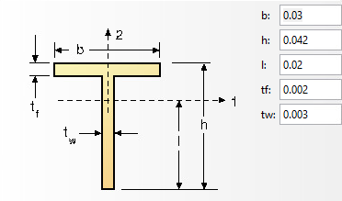
As we can see in this picture, the T-beam beam profile in the ABAQUS software has four inputs: b-base, h-height, tf-thickness of the flange, and tw-thickness of the web. Lastly, "I" is the center of gravity, which we calculated using an online calculator.

After a few trials runs, my model started converging on the specifications shown in the image above. These specifications result in maximum stress of 267 [MPa], which is within the 5% error of the ideal stress of 266.6 MPa, which we found using the design factor formula.
For my model, I used different mesh qualities in various locations. I used lower-quality meshes for most trusses because I did not need high accuracy in those locations. However, because we had previously discussed how mesh size affects the results of a model, mainly when a dimension-dependent load was applied, I used a higher quality mesh on the beam where the line loads were placed to get higher sensitivity, resulting in a more accurate result.

JACOB VAUGHT:
$$\frac{6*500}{266*{10}^{6}}=BH^{2}$$
If the formula above is graphed, it approaches 0 in the B and H direction. If we take its derivative, it is found that to optimize the function for Cross-Sectional Area, B must approach 0, while H approaches infinity. Thus, it can be said that as B approaches 0 and H approaches infinity, the cross-sectional area approaches 0. This can also be seen analytically, as it can be inferred that$∞*0=0$. The above statement concludes that a genuinely optimized beam design will never be reached, so the results of any project such as this can be considered unlikely to be helpful in any realistic scenario.
This section will show that the results of this project prove what had been calculated above. The equation above is simply inaccurate because it is modeled assuming that the beam with a load applied is supported at both ends with simple support. After approximately 20 trial runs, an approximate size was determined for the "Box" beam profile. It was determined that width(a) is equal to 0.001 m, height (b) is equal to 0.307 m, Vertical wall thickness (t1, t3) is equal to 5E-05, and Horizontal wall thickness (t2, t4) is equal to 1E-05. Using A general Formula for calculating the Cross-section area of a "Box,"
$b*a-\left(a-(t1+t3)\right)\left(b-\left(t2+t4\right)\right)$, which gives a cross-sectional area of 0.000030718 m² equal to 0.30718 cm² or 30.718mm².
For the mesh of this model, I used a combination of initial estimates and intelligent techniques for determining where to apply a higher quality mesh. After a first trial run with the mesh size set to 0.1, I determined that the significant stress point would be (4,0) at the Roller Support. Because Line loads can be drastically affected by mesh size, I determined that it would be best to make the 2-meter beam from (4,0) to (6,0) have a higher quality mesh. Unfortunately, my first choice of 0.001 seed was unviable due to the constraint on the Student Version of Abaqus, which limits Student versions to 1000 nodes. My model would have exceeded 2000 nodes if I used a 0.001 seed, so I used a 0.01 seed. Of the 4 group members, my model was the most efficient, with a minimum cross-section of approximately 30.718mm². Below are some graphs detailing the effect height and width had on stress.

By adjusting the height of the rectangular box and keeping all other variables constant, we can see that height influences the maximum stress in the model.
By adjusting the width of the rectangular box and keeping all other variables constant, we can see that width has some influence on the maximum stress; however, height still has a more significant impact.

JACOB WHISENANT:
This project consisted of multiple ABAQUS tests performed on 4 different beam profiles. The goal was to find the most optimal cross-sectional area in line with the problem description’s desired design factor and other given parameters. In the last portion of the report, a circular beam profile was chosen and simulated through ABAQUS. The conducted simulation showed that a bridge frame can be constructed from this beam profile, fit the parameters required by the design factor, but may not be the best choice when given other options. The reason being is the circular beam design, while suitable to bear the load of 266MPa, is unable to achieve a lower cross-sectional area. In designing a bridge this would be undesirable towards the cost and the material waste. Given the required conditions of the failure stress of the material being 400MPA, the design factor being set to 1.5, young's modulus of 200GPa, and Poisson's ratio of 0.3, a minimum cross-sectional area was found to fit the desired requirements. The minimum allowable cross-sectional area using radius 0.011495m equates to (4.151x10-4) m^2 and allows for a maximum of 266MPa.
In ABAQUS there are 11 different beam profiles to select from. The circular beam profile, as seen above, is simple as it only requires one user input. Inputting a radius will create the cross-sectional area of the beam, which will have a direct effect on the max load that it can bear. The goal of the project was to design a minimalistic bridge truss that can support the (400/1.5) MPa. This beam profile was tested on a range of radii and then ran through the simulator. Comparing this value to the other values obtained with different beam profiles, the circular beam is the least efficient.
The solution approach required for setting up a 2D beam frame in Abaqus CAE started with creating the sketch of the part. Then setting the material type to the given elastic parameters. After that, the frame sections are set and configured to that of a circular beam profile with an estimated radius. Then the created sections were assigned to the entirety of the part. Next, set the geometry for the orientation assignment; in this case, since it is circular, the orientation has no effect. Then create the dependent instance type on the part. Then mesh and seed the part. Smaller seeds are not required through the integrity of the mesh, only where the most accuracy is needed, which in this case is the truss supporting the load. Next, create a static, general step. After that, the proper boundary conditions need to be placed alongside the desired line load and then finish with the job's creation. This concluded with the viewable results of the test. This process was completed for multiple iterations of the model with different radii until max stress (400MPa/1.5) was found for the lowest possible cross-sectional area.

CONCLUSIONS:
Upon completion of project 1, group 3 gained some insight into the behavior of the four beam profiles previously discussed. The rectangular beam style was determined to be the most efficient because all other models, except the circle, started to converge on the rectangular shape. The formula discussed previously shows that a line with infinite length would be the most efficient. The circle beam profile is the least efficient because it fails to achieve the lowest minimal cross-section area out of all the bridge frame designs tested, resulting in a waste of material and cost. This project gave the group 3 members a newfound knowledge of Finite Element Analysis modeling applications. 2D simulations are the cornerstone of many great modeling and testing scenarios that help engineers understand the world around them, but 2D models are too limited for more realistic scenarios, such as producing a bridge truss system. A 3D model is recommended for anything more complicated. All group 3 members also came to appreciate the fact that ABAQUS is a powerful tool for models like this.

